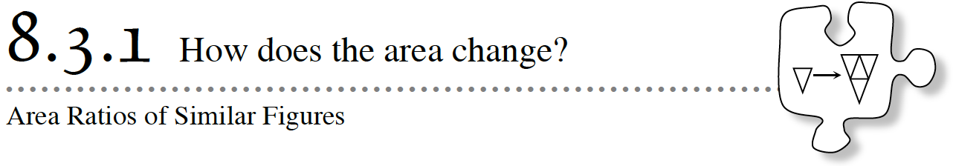
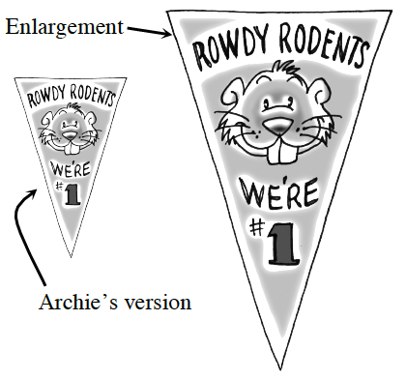
8-53 - MIGHTY MASCOT
To celebrate the victory of your school’s championship girls’ ice hockey team, the student body decides to hang a giant flag with your school’s mascot on the gym wall. To help design the flag, your friend Archie creates a scale version of the flag measuring 1 foot wide and 1.5 feet tall.

- If the final flag should be 3 feet tall, how wide should this enlarged flag be?

- If Archie uses $2 worth of materials to create his scale model, how much will the materials cost for the full-sized flag?

- Obtain the Lesson 8.3.1A Resource Page. Cut enough copies of Archie’s scale version to fit into the large flag. How many did it take? Does this confirm your answer from part b?

- The student body is now reconsidering the size of the flag. Now, you need to enlarge the flag so that it is three or four times the width of Archie’s model. How much would the materials for a similar flag that is three times as wide as Archie’s model cost? To answer these questions, first estimate how many of Archie’s small flags would fit into each enlarged flag. Then, obtain the Lesson 8.3.1B Resource Page for your team and confirm each answer by fitting Archie’s small flags into the enlarged ones.

Measure in feet of enlarged flag | Number of small flags | Materials cost in $
1 | 1 | $2
2
3
4

8-54
Write down any observations or patterns you found while working on problem 8-53. For example, if the area of one shape is 100 times larger than the area of a similar shape, then what is the ratio of the corresponding sides (also known as the linear scale factor.)

If the linear scale factor is r, how many times larger is the area of the new shape? _________________

8-55 - Application Problems
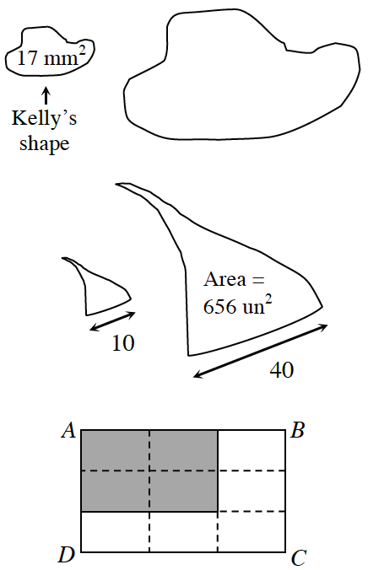
a) Kelly’s shape at right has an area of 17 mm². If she enlarges the shape with a linear scale factor of five, what will be the area of the enlargement?

b) Examine the two similar shapes at right. What is the linear scale factor?

What is the area of the smaller figure?

c) Rectangle ABCD at right is divided into nine small congruent rectangles. Is the shaded rectangle similar to ABCD? If so, what is the linear scale factor? What is the ratio of the areas?

d) While ordering carpet for his rectangular office, Trinh was told by the salesperson that a 16′ by 24′ piece of carpet costs $800. Trinh then realizes that he read his measurements wrong and that his office is actually 8′ by 12′. “Oh, that’s no problem,” says the salesperson. “That is half the size and will cost $400 instead.” Is that fair? Decide what the price should be.

8-56 - HEXAGONS
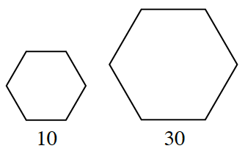
If the side length of a hexagon triples, how does the area increase? Calculate and compare the areas of the two hexagons.

